

IM3080 Design and Innovation Project
(AY2022/23 Semester 1)
Project Report

Title: Flowerescent
Github: https://github.com/Eternalmadhatter/Flowerescent
Submitted by: Group 7
Supervisor: Assoc. Prof Chua Hock Chuan

Table of Content
1. Background and Motivation 3
2. Objective 3
3. Review of Literature/Technology 4
Table 1: Arduino Libraries Used 4
3.2 Supplies Required 4
3.3 Software Coding and Implementations 4
4. Design and Implementation 7
4.1 Design Consideration / Choice of components 7
4.2 Final Design (with block diagrams) 8
4.3 Implementation (with photos) 9
4.4 Discussion 11
5. Conclusion and Recommendation 13
5.1 Conclusion 13
5.2 Recommendation for Future Works 13
6. Appendices 14

Background and Motivation
With the increasing number of plastic pollution cases around the world, it has become one of the most serious global issues. Plastic pollution is the accumulation of plastic objects and particles in the environment. The main cause of plastic pollution is caused by littering. This pollution can alter habitats and natural processes, reducing the ecosystem's ability to adapt to climate changes and affecting millions' social well-being.
Instead of abstaining from the use of plastic, another approach to returning to nature would be through upcycling. Plastic upcycling would reduce the amount of plastic that would end up polluting the environment. Hence, we chose to redesign and improve "Lumière," a past project done by seniors.

2. Objective
The objective of this project is to design an artwork with energy-saving lighting, ambient nature sounds and environmentally friendly materials.
This project encourages and serves as a reminder to the general public to adopt sustainable habits in their everyday lives. We hope to raise awareness about the harmful effects of plastic pollution and waste and educate people about the need to reuse and recycle.

3. Review of Literature/Technology
3.1 Required libraries / API implemented in Flowerescent
 | Libraries Used | Descriptions
Visual | FastLED.h | - Fast, efficient, compatible LED driver code for WS2811 LED  - Provides full HSV colour support as well as classic RGB
Visual | Wire.h | - Allow communication with I2C/TWI devices
Audio | PCM.h | - Playbacks short audio samples  - Samples are encoded directly in the Arduino sketch as an array of numbers
Audio | SoftwareSerial.h | - Allows serial communication on other digital pins of an Arduino board

Table 1: Arduino Libraries Used

3.2 Supplies Required
- Two Arduino Unos
- 5V Poweqr Supply
- WS2811 LED Strips
- Serial MP3 Player Module(UART)
- Speaker
- Pressure Sensor

3.3 Software Coding and Implementations
- Master and Slave System
The use of a master and slave architecture combines visual and audio works, allowing us to optimize I/O in our application through workload distribution. The master controls the sensor and visual designs, whereas the slave handles the audio effects. This enhances our performance as actions can now be processed in parallel. Flowerescent has been programmed to detect the load on each pressure sensor. This will then activate the flower lights (WS2811 LED pixel strips) and the serial MP3 player (UART).
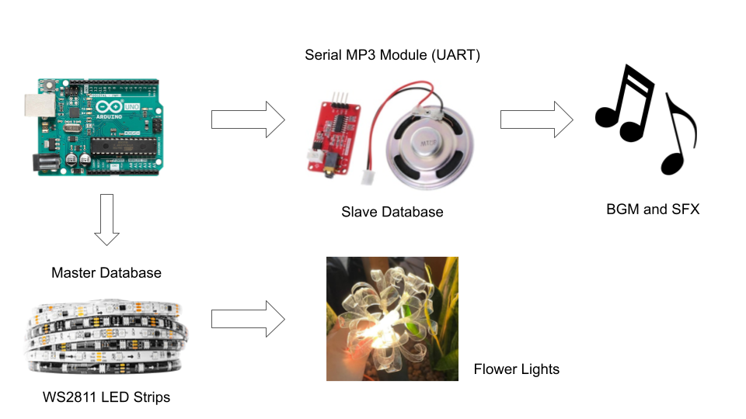
Table 2: Visualisation of an implementation

- Visual Effects
A total of three pressure sensors have been planted on the stone bases. There are a total of 4 different designs based on the user’s interaction with Flowerescent.
Visual Effects | Condition
Sinelon lights | No user interacting with Flowerescent
Ripple yellow and tangerine lights | When user steps on the first stone base
Ripple blue and purple lights | When user steps on the second stone base
Ripple red and pink lights | When user steps on the third stone base
Table 3: Lighting effects
If a user steps on two stone bases at the same time, priority will be given to the highest-numbered stone. When there are no users interacting with Flowerescent, the flowers will play a Sinelon visual effect, which displays a colored dot sweeping back and forth with fading trails.
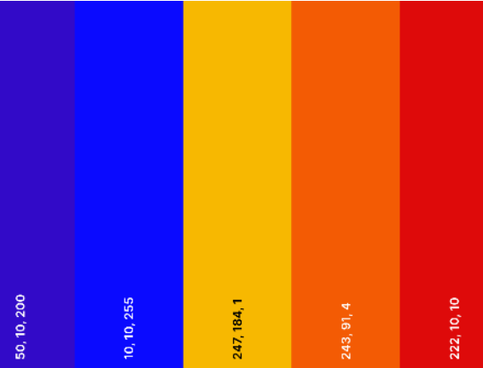
Table 4: Colour palette for visual effects

- Audio Effects
Audio Effects | Condition
BGM loops (River) | No user interacting with Flowerescent
Mud | When user steps on the first stone base
Grass | When user steps on the second stone base
Flapping | When user steps on the third stone base
Table 3: Audio effects

4. Design and Implementation

4.1 Design Consideration / Choice of components
We chose the flower Lycoris radiata, also known as the red spider lily, as it symbolises the cycle of rebirth, which corresponds to our topic upcycling — giving them a second life. Hence, throughout the project, we made an effort to upcycle materials from past projects.
Components Used | Design Considerations
Plywood base | - Sturdy material to hold up our entire project  - Material was scrap material from the Lab  - Prevents the wires from touching the floor
Polyfoam base | - Able to hold up the weight of people  - Easy to work with and shape
Reused styrofoam steps | - Repurpose the styrofoam blocks from previous project  - Dense enough to carry human’s weight  - Able to sculpt the styrofoam blocks into a rock-like structure
Reused acrylic “stalks” | - Previously used in another project “Lumière”  - The material suits the theme and design of the project - flowers and upcycling  - Able to withstand the weight of the plastic flowers and remain upright
Plastic (recycled) flowers | - Design is inspired by Lycoris radiata, red spider lily  - Made from recycled transparent plastic bottles as it allows lights to pass through and create a luminous effect (Aesthetics)  - We used food containers as they are more easily obtained and each of them can make more flowers thus more feasible. However, they are less transparent so the effect is not as significant but it works fine as well  - The materials used are cheap, recyclable, easy to obtain, heats up evenly for curling, and aesthetically pleasing
Fishing line | - Used to recreate the stamen from spider lily, it is slightly curled which highly resembles the actual flower stamen  - Highly transparent to correspond to the pedals aesthetically and to trap the light, giving it a luminous effect
Pressure Sensor | - To trigger an effect when someone steps on it for interaction  - The ultrasonic sensor was too sensitive and is not as suitable

4.2 Final Design (with block diagrams)
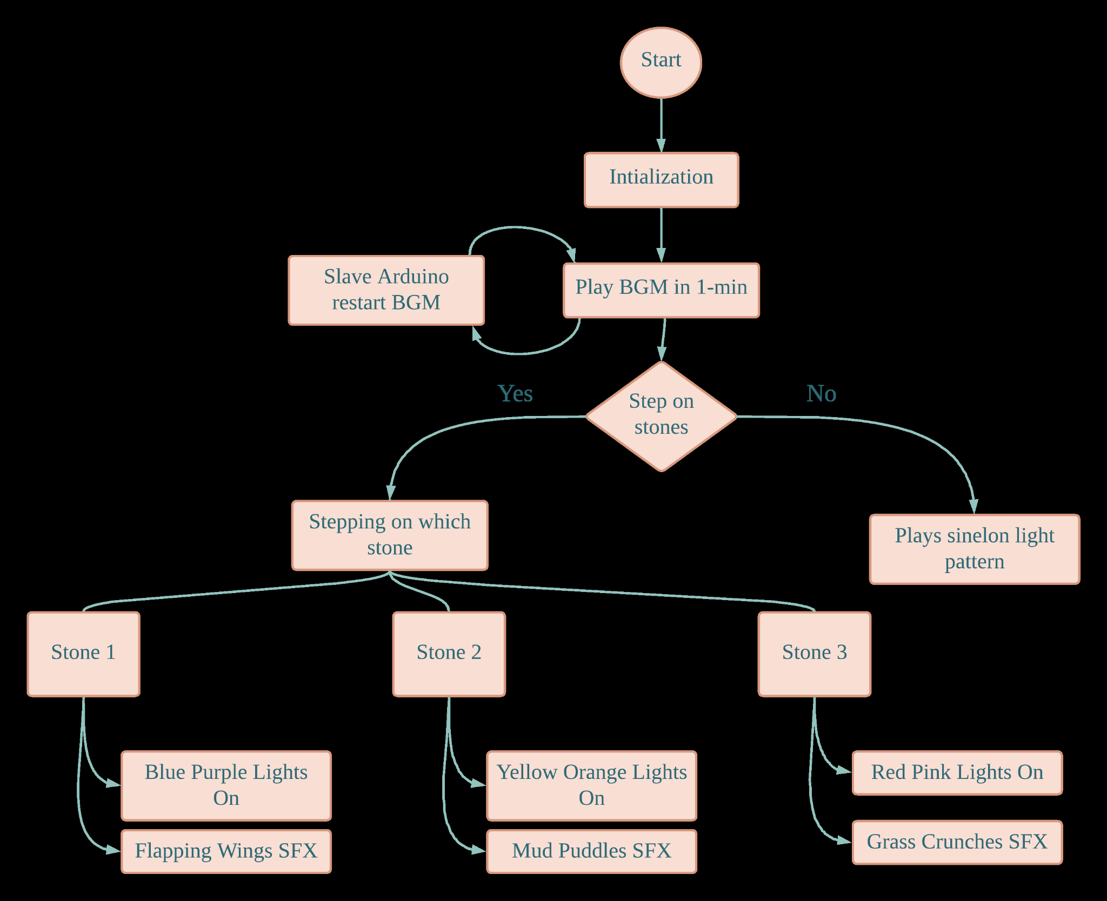
Figure 1: Block Diagram of Master-Slave programme flow

4.3 Implementation (with photos)
The entire set up mainly comprises the stone steps and the flowers. The stone steps symbolises the efforts placed in upcycling, where we encourage changes through small and meaningful steps.
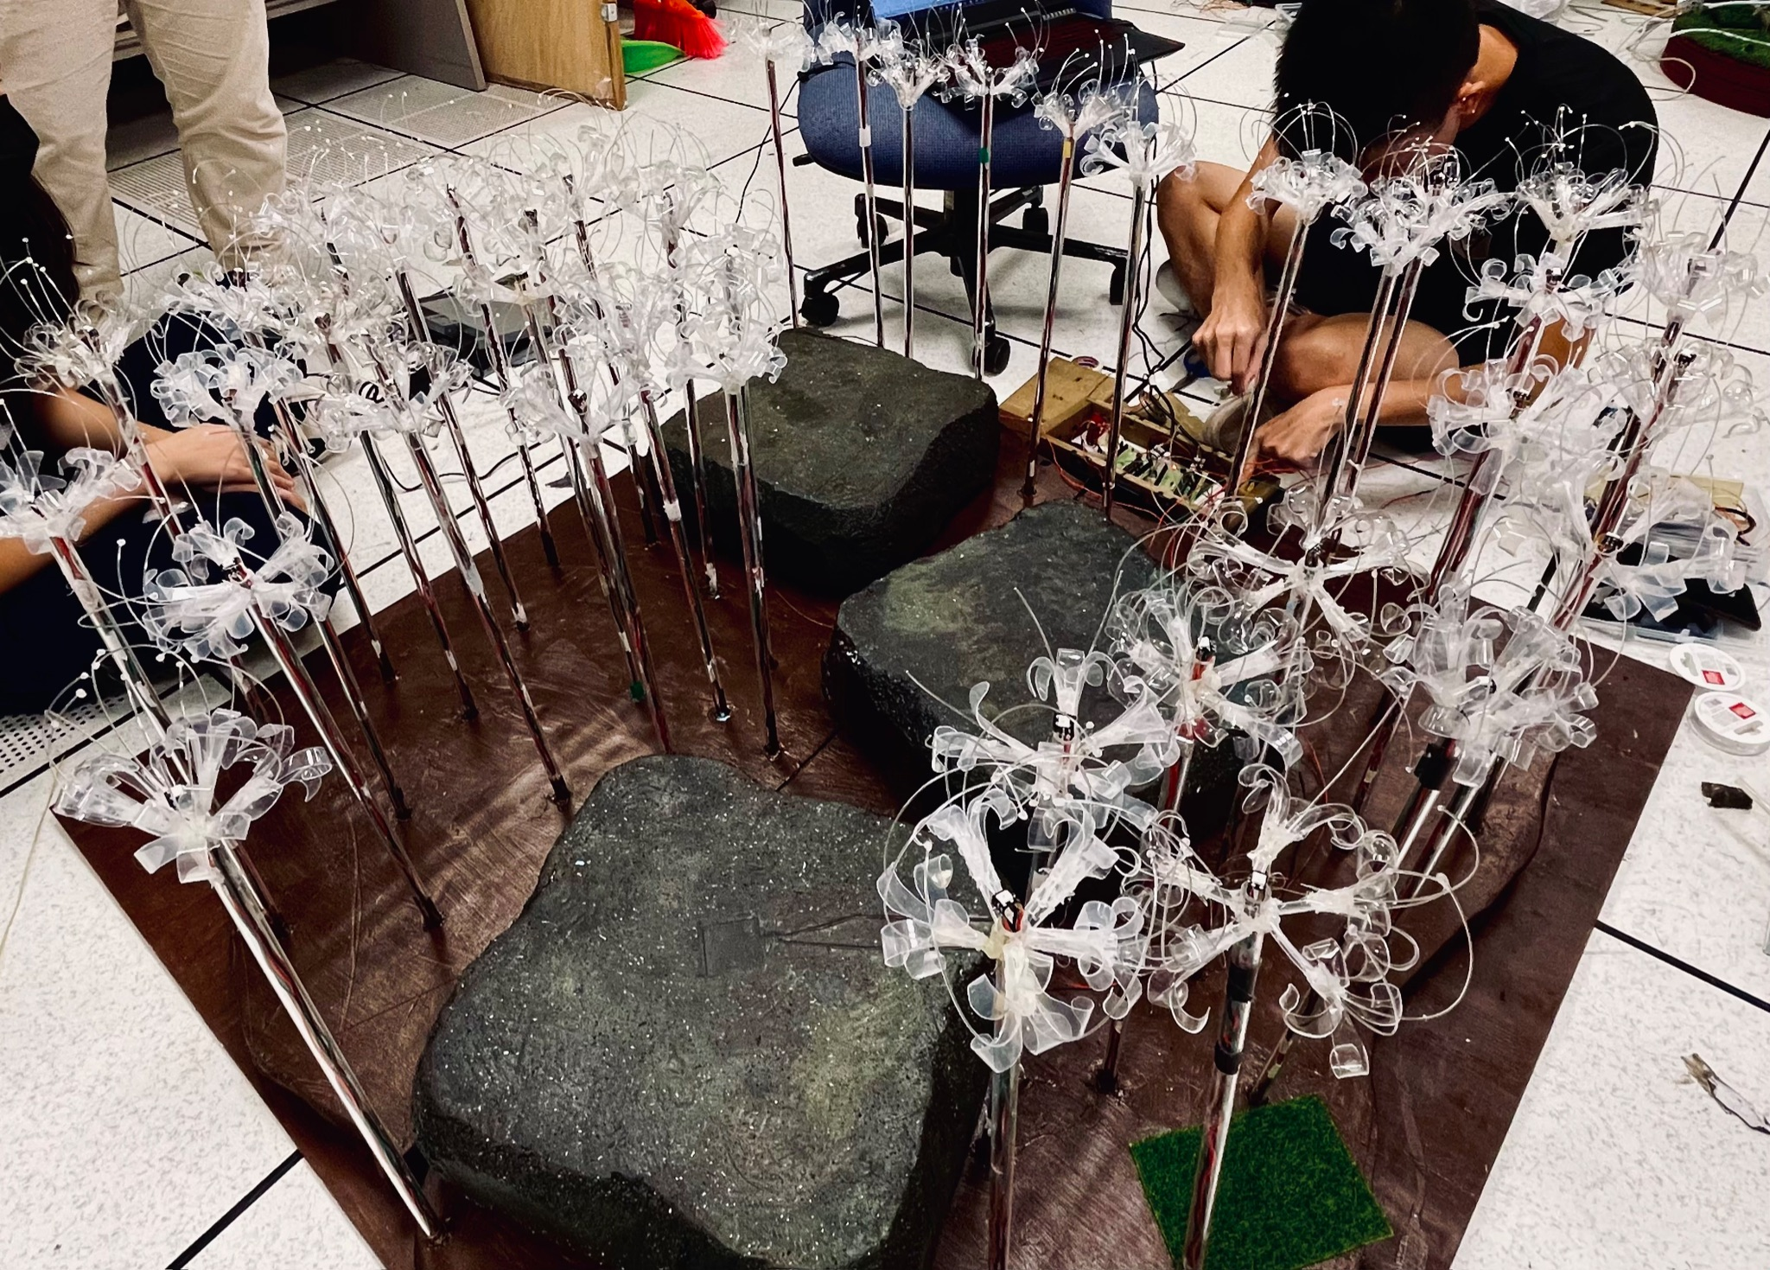
Figure 2: Final design of our project
The flowers will light up randomly when left alone, portraying the concept of freedom and beauty of nature. When someone steps on the step, it will trigger a rippling effect of the lights to indicate how every small step can create an impact on nature.
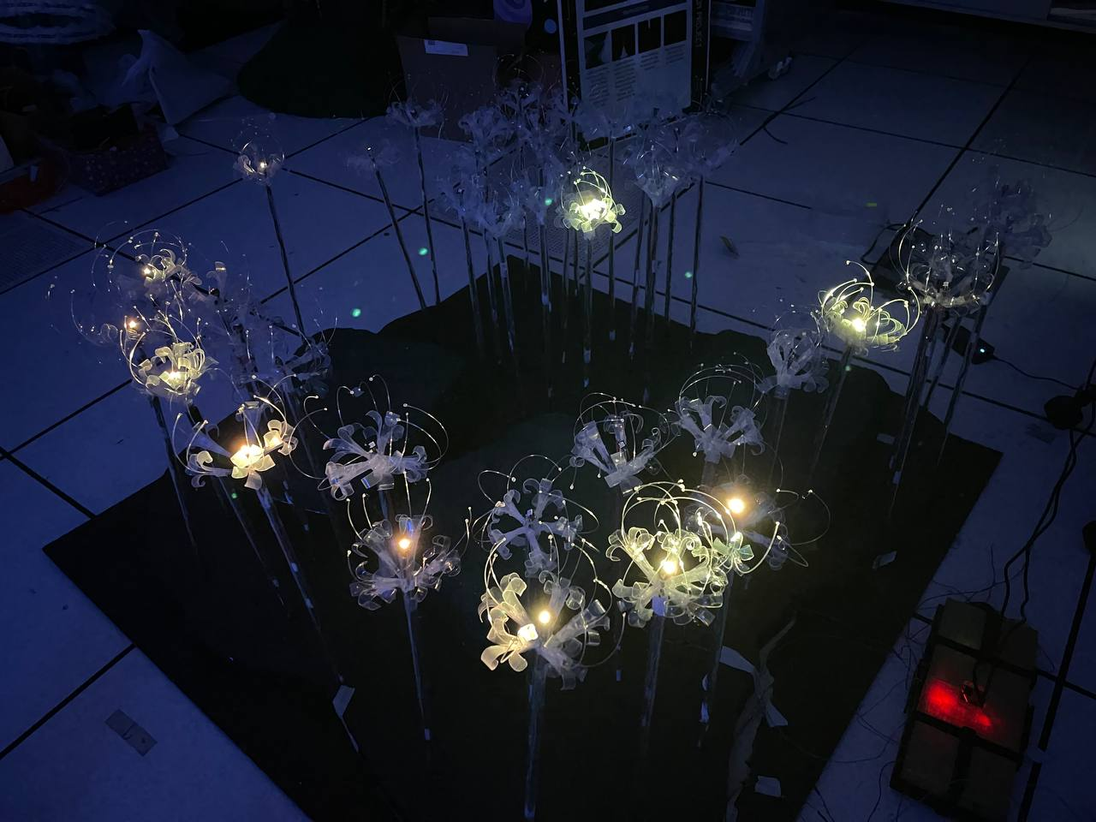
Figure 3: Light when left alone
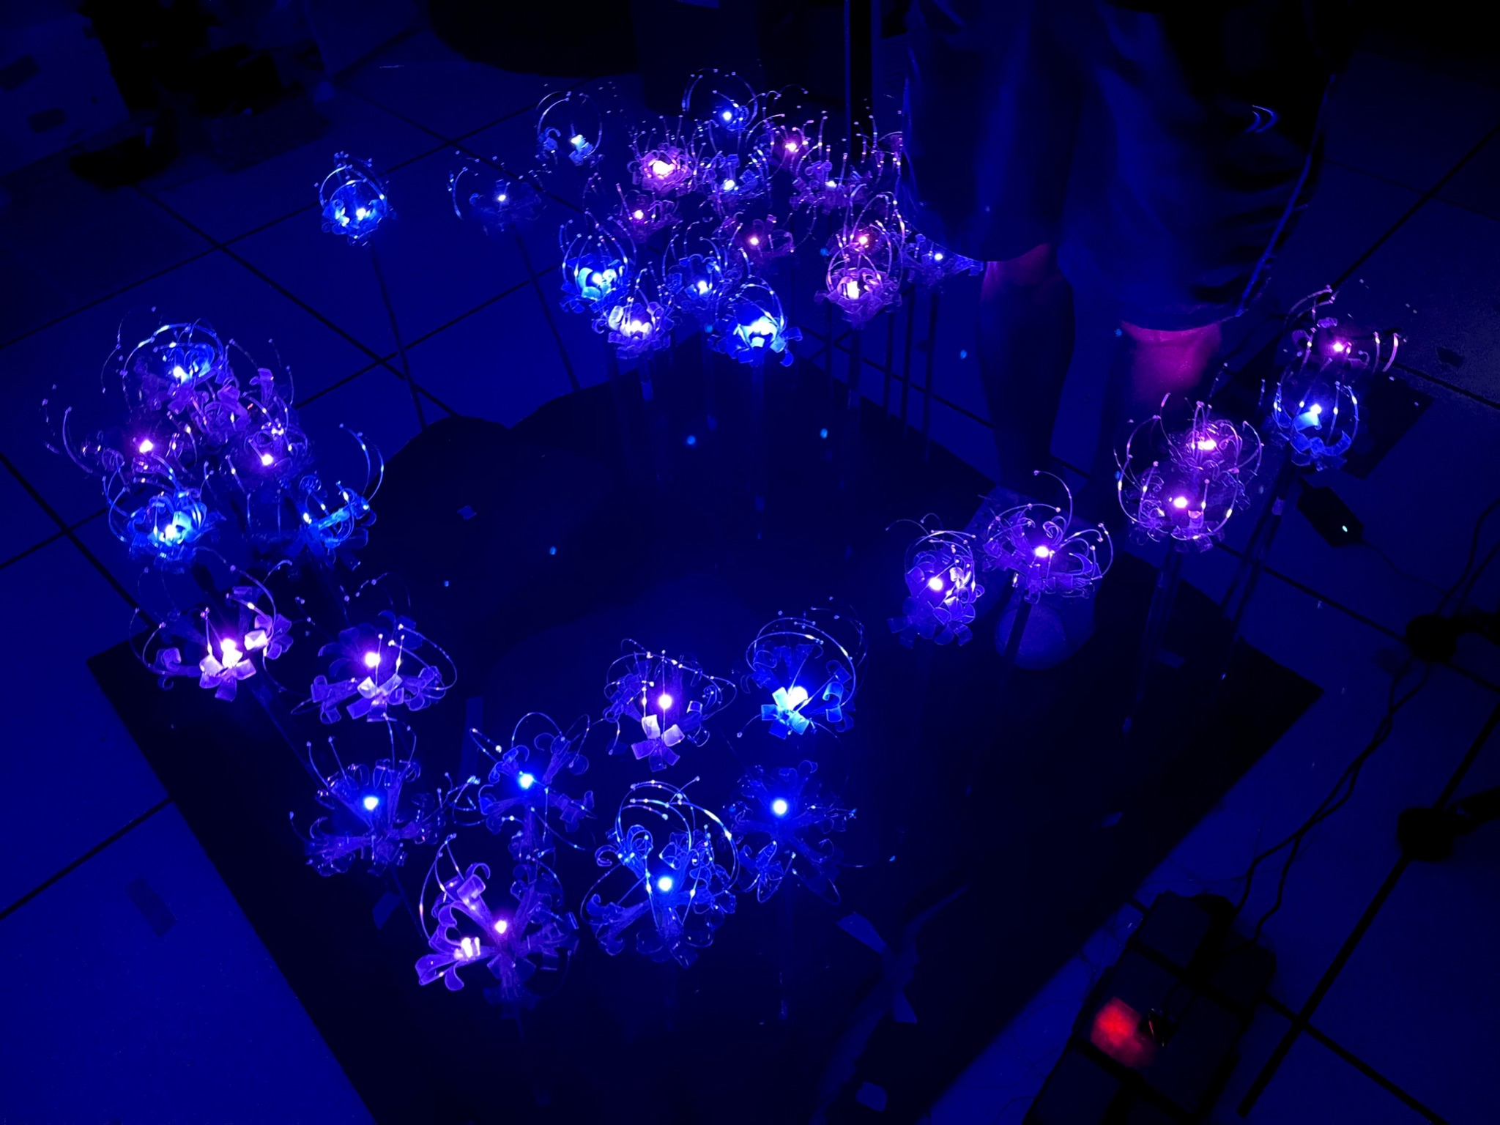
Figure 4: Lights during Rock 1
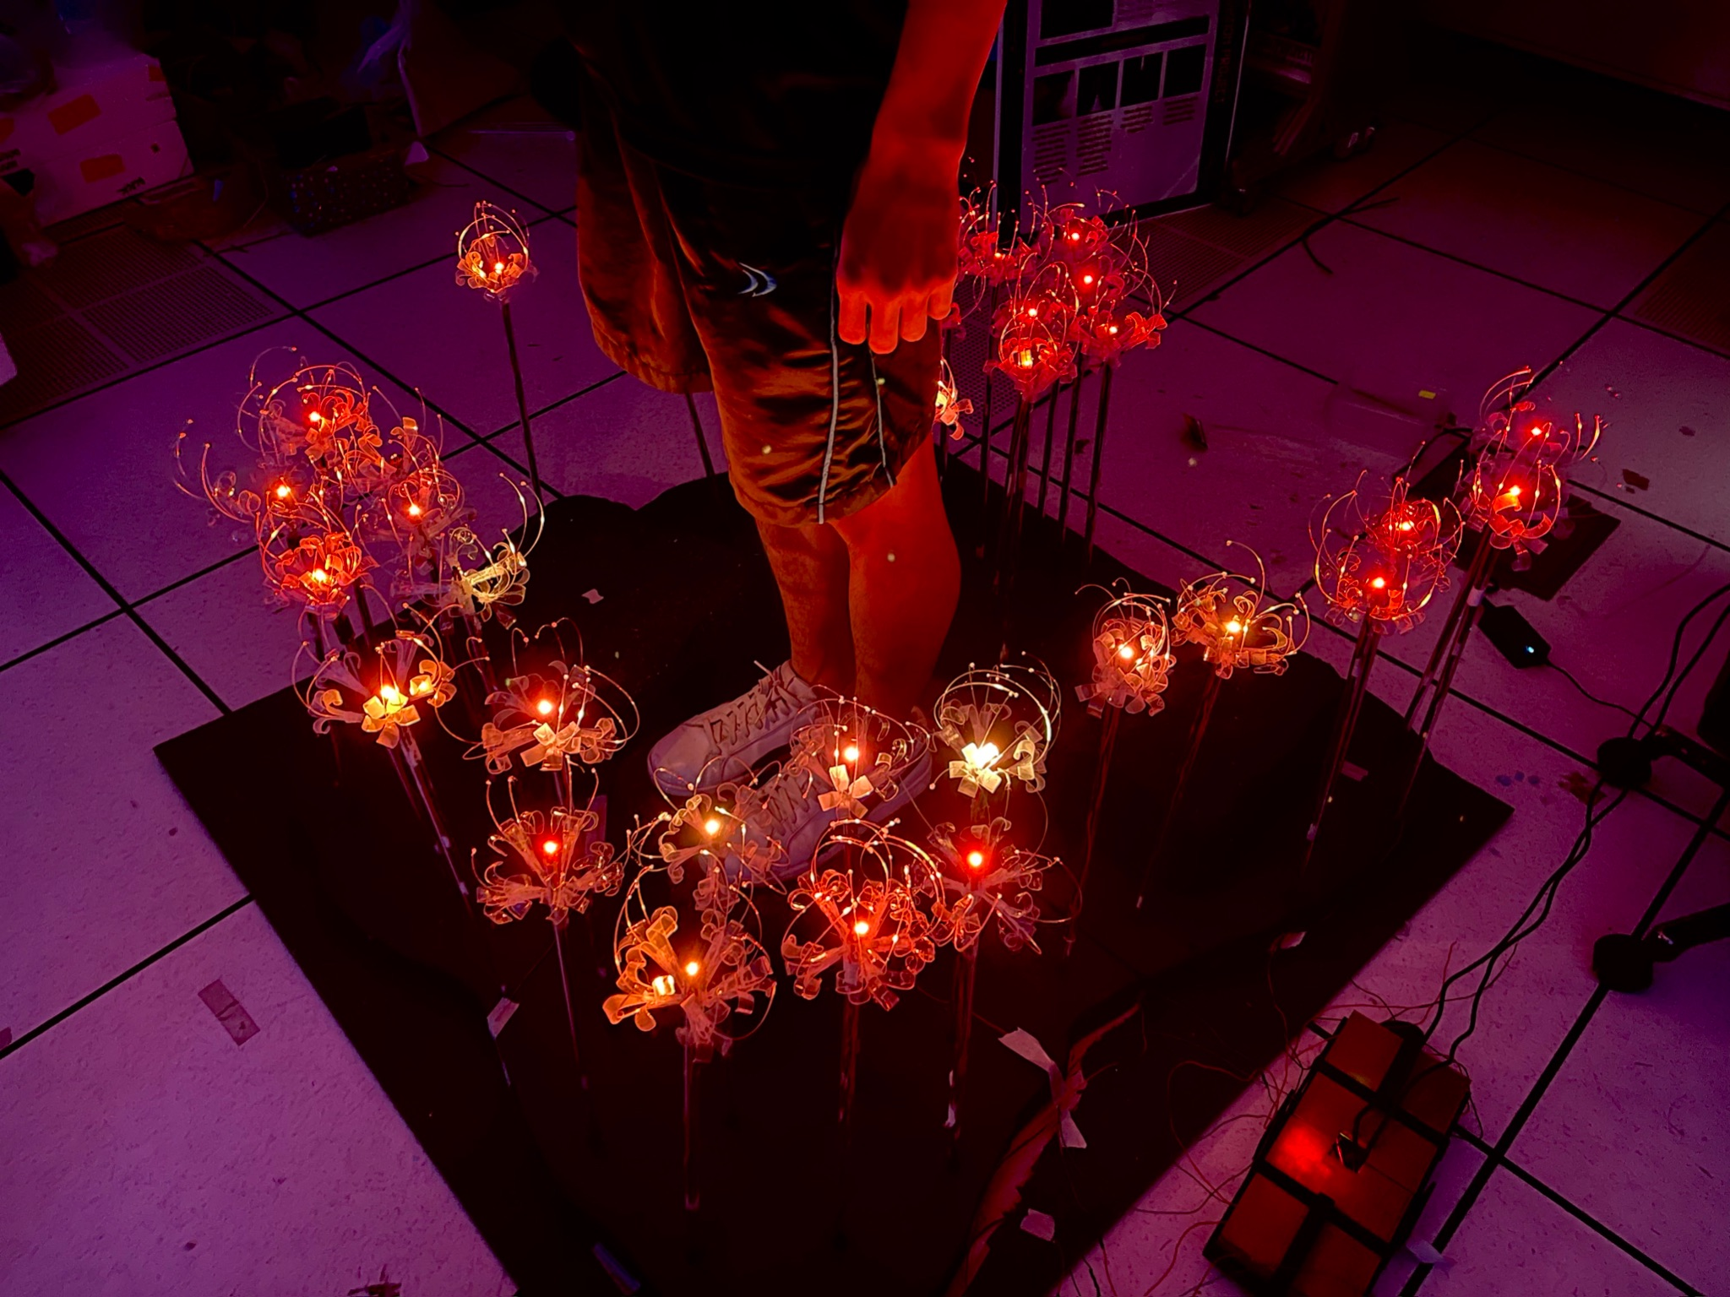
Figure 5: Lights during Rock 2
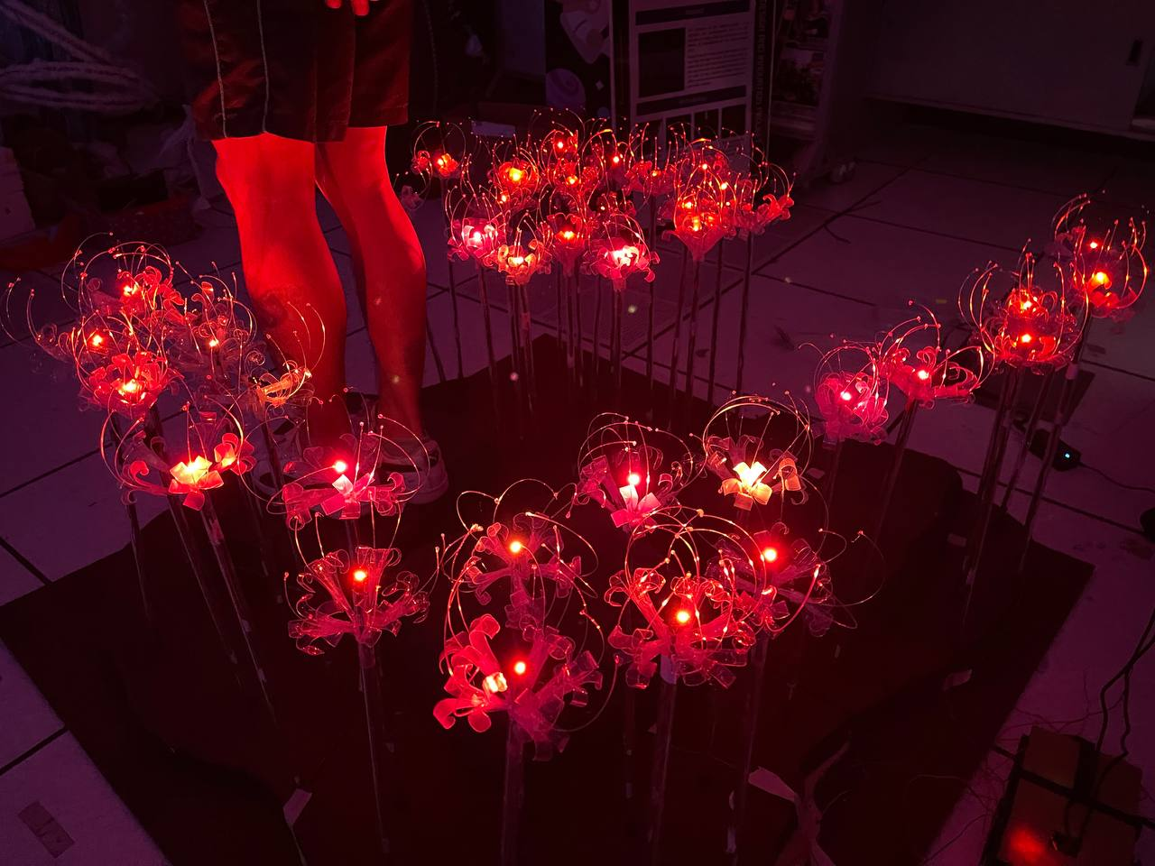
Figure 6: Lights during Rock 3

4.4 Discussion
At the beginning of our project, we had lots of different ideas on how we can reinvent the previous project. We wanted to have elements of:
- A walkway
- Having interaction
- Educational purpose
Once we decided on the concept and features of our project, we split ourselves into sub-groups:
- Design
- Lights
- Sound
The design team had issues with the walkway because we were limited with space. Therefore, after many brainstorming sessions, we decided to create a stepping stone platform, with every step being activated by the weight. As we were creating the prototype, we realised that the area we wanted to do would require us to make too many flowers, hence we decided to reduce our project scale smaller to create a stone pathway.
With the new idea in place, we started full production of creating 40 plastic flowers as well as deciding on the rest of the materials we would need to create the project. Meanwhile, the lights and the sound team were already progressing well with their codes and testing different hardwares.
As we were progressing, we faced many challenges but smoothly found solutions. The key features of our project include:
- LED flower with different reactions
- Sound activated by pressure sensors
- Stone pathway with pressure sensors built in

5. Conclusion and Recommendation

5.1 Conclusion
Though we had a previous project to provide us with inspiration, it was not an easy task trying to improve the project and make it our very own. Being in a team of 10, we learnt a lot regarding teamwork, such as communication, delegation of tasks and continuously improving on our project.
Through hours of hard work, we stepped up from being unfamiliar with Arduino, to familiarising ourselves on how to set-up and run simple codes. Having gone through various iterations and redesigns based on feedback from team members and professors, we are now much more aware of the various considerations one should take into account when doing a hardware project. This will ultimately be able to help us smoothen the development process in the long run.
We hope that through this project, people can realise the significant amount of plastic they produced and start to be more mindful about their plastic usage. Beyond just knowledge, we hope that action would be taken possibly in the future, to cut down on plastic usage and adapt to sustainable habits.

Recommendation for Future Works

Due to time constraints, there are a few features which we were not able to implement currently. In future, developers could work on these ideas:

Further development of design assets. For example, creating a mechanism in the flower to ‘bloom’ flowers when stepping on pressure sensors
- Possibility of adding a fan mechanism to mimic wind in garden
- Enhancing the light component, making use of more LED lights to create more dynamic flower lighting
- Adding of other audios so that user can hear different variety of sound when stepping on the stone
- LED sign board to display title of project and direct users to walk through the pathway

6. Appendices
A. (For project with hardware expenses) Bill of Materials (BOM) – “All spending” AND “for the project prototype”
Item | Quantity | Purchase amount ($S)
Pressure sensors | 6 | 43.54
Set of 3 2’ Polyfoam | 1 | 49.90
Acrylic paints (Blue, Red, Yellow, White & Brown) | Blue, Yellow, Red - 3  White - 6  Brown - 1 | 36.94
 | Total | 130.38

B. Source Code (Github Repositories)
https://github.com/Eternalmadhatter/Flowerescent

